Firewall-as-a-Service (FWaaS)

The Firewall-as-a-Service (FWaaS) plug-in adds perimeter firewall management to OpenStack Networking (neutron). FWaaS uses iptables to apply firewall policy to all virtual routers within a project, and supports one firewall policy and logical firewall instance per project.
FWaaS operates at the perimeter by filtering traffic at the OpenStack Networking (neutron) router. This distinguishes it from security groups, which operate at the instance level.
NOTE
FWaaS is currently in technical preview; untested operation is not recommended.
The example diagram below illustrates the flow of ingress and egress traffic for the VM2 instance:
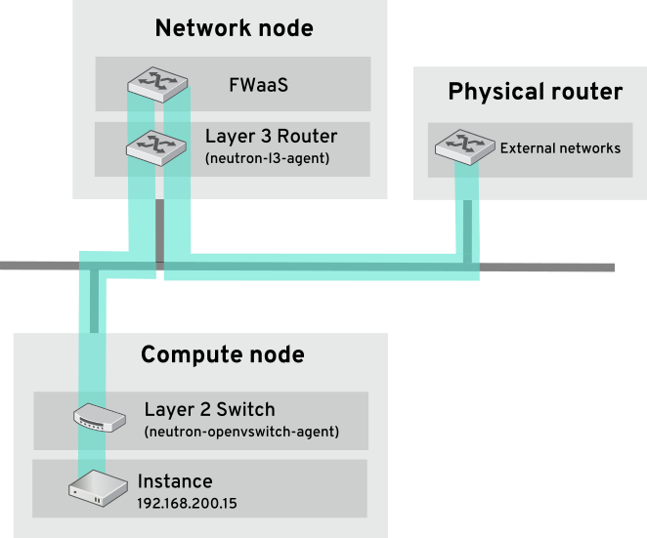
https://docs.openstack.org/neutron/train/admin/fwaas-v2-scenario.html

